ELEG 312 - Example Problems Chapter 9-3

**Problem 9.91**

Figure P9.91 shows the active-loaded MOS differential amplifier prepared for small-signal analysis. To help the reader we have already indicated approximate values for some of the node voltages. For instance, the output voltage $v_{o}=0.5\left(g_{m}r_{o}\right)v_{id}$, which we have derived in the text. The voltage at the common sources has been found to be approximately ${{+v}_{id}}/4$, which is very far from the virtual ground one might assume. Also, the voltage at the gate of the mirror is approximately ${{-v}_{id}}/4$ confirming our contention that the voltage there is vastly different from the output voltage, hence the lack of balance in the circuit and the unavailability of a differential half-circuit. Find the currents labeled *i*1 to *i*13. Determine their values in the sequence of their numbering and reflect on the results. You will find that there is some inconsistency, which is a result of the approximations we have made. Note that all transistors are assumed to be operating at the same $\left|V_{OV}\right|$.

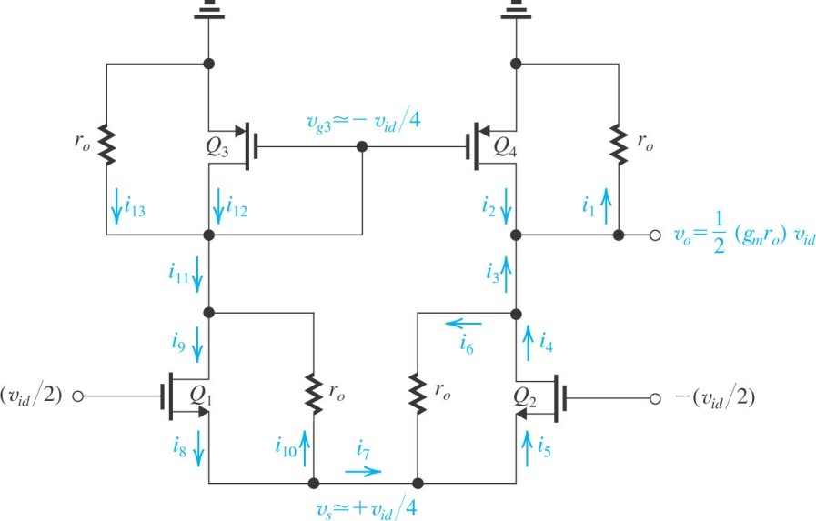

**Problem 9.92**

A current-mirror-loaded NMOS differential amplifier operates with a bias current *I* of 200 μA. The NMOS transistors are operated at *VOV* = 0.2 V and the PMOS devices at |*VOV*| = 0.3 V. The Early voltages are 20 V for the NMOS and 12 V for the PMOS transistors. Find *Gm*, *Ro*, and *Ad*. For what value of load resistance is the gain reduced by a factor of 2?